TASK 4:
Answers
1) Program – Checking and comparing sum of numbers
package java_Tasks;

import java.util.Scanner;

public class Task1_IntroductionToJava {

public static void main(String[] args)
{
//Question 1 :

System.out.println("Enter the numbers");

Scanner sa = new Scanner(System.in);
int a = sa.nextInt();

Scanner sb = new Scanner(System.in);
int b = sb.nextInt();

Scanner sc = new Scanner(System.in);
int c = sc.nextInt();

Scanner sd = new Scanner(System.in);
int d = sd.nextInt();

System.out.println(a + " " + b + " "+ c+ " "+d);

int e = a+b;
int f = c+d;

if (e>f)
{
System.out.println("The sum of a and b is greater than the sum of c and d");
}
else
{
System.out.println("a and b not greater than c and d");
}
sa.close();
sb.close();
sc.close();
sd.close();
}

}

Output:
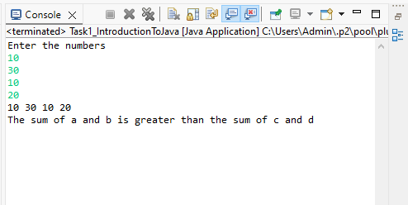

2) Program – check for Even_number:
package java_Tasks;

import java.util.Scanner;

public class Task1_CheckEvenNumber {

public static void main(String[] args)
{
// TODO Auto-generated method stub
System.out.println("Enter a number");

Scanner sa = new Scanner(System.in);
int i = sa.nextInt();

if (i%2==0)
{
System.out.println(i + " is an even number");
}
else
{
System.out.println(i + " is an odd number");
}
sa.close();
}

}

Output:

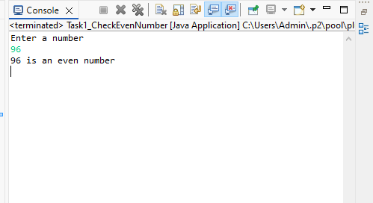

3) Program – Printing alphabets A-Z:

package java_Tasks;

public class Task1_PrintA_to_Z {

public static void main(String[] args)
{
// TODO Auto-generated method stub
System.out.println("Printing characters from A to Z");

for (char c = 'A'; c<= 'Z'; c++)
{
System.out.println(c);
}
}

}

Output:
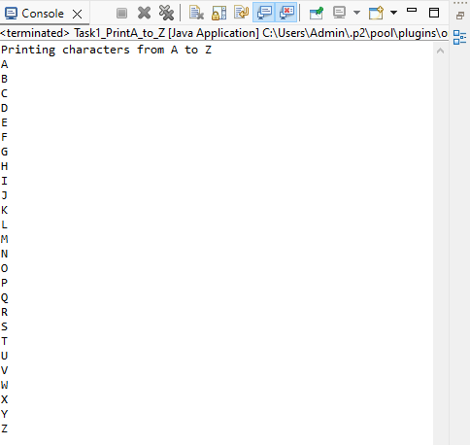

4) Program – Swapping 2 Numbers:
package java_Tasks;

import java.util.Scanner;

public class Task1_Swapping {

public static void main(String[] args)
{
// TODO Auto-generated method stub

System.out.println("Enter 2 numbers");

Scanner sa = new Scanner(System.in);
int a = sa.nextInt();

Scanner sb = new Scanner(System.in);
int b = sb.nextInt();

int temp;

System.out.println("Numbers before swapping" +" "+ a + " "+ b);

temp = a;
a=b;
b=temp;

System.out.println("Numbers after swapping" +" "+ a + " "+ b);

sa.close();
sb.close();
}

}

Output:
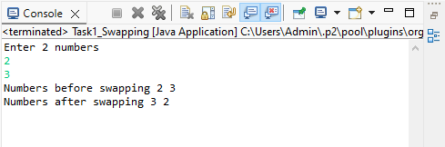

5) Program – Check Prime number:

package java_Tasks;

import java.util.Scanner;

public class Task1_PrimeNumber {

public static void main(String[] args)

{
// TODO Auto-generated method stub

System.out.println("Enter a number");

Scanner sa = new Scanner(System.in);
int a = sa.nextInt();
int count = 0;

for (int i=1; i<=a; i++)
{
if(a%i==0)
{
count++;
}

}
if(count==2)
{
System.out.println("Number is a prime number");
}
else
{
System.out.println("Number is not a prime number");
}

sa.close();
}
}

Output:

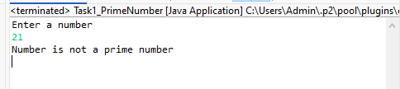

6) program – Factorial of given number:
package java_Tasks;

import java.util.Scanner;

public class Task1_Factorial {

public static void main(String[] args) {
// TODO Auto-generated method stub
System.out.print("Enter the number :");
Scanner s = new Scanner(System.in);
int num = s.nextInt();
long f = 1;

if (num < 0) {
System.out.println("Cannot find Factorial for Negative numbers");
}
else
{
for (int i = 1; i <= num; i++)
{
f = f*i;
}
System.out.println("Factorial of " + num + " is: " + f);
}
s.close();
}
}

Output:
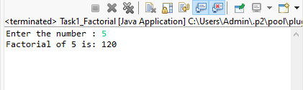
7) Program – Find length of string:
package java_Tasks;

import java.util.Scanner;

public class Task1_LengthOfStrng {

public static void main(String[] args)
{
System.out.println("Enter the string");
Scanner sc=new Scanner (System.in);
String Str=sc.nextLine();
System.out.println("Enter the string");
System.out.println(Str.length());
}
}

Output:
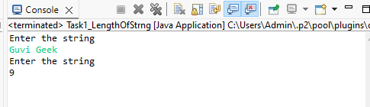

8) Program: Print “Welcome to Guvi” 10 times:

package java_Tasks;

import java.util.Scanner;

public class Task1_WelcomeToGuvi {

public static void main(String[] args)
{
// TODO Auto-generated method stub
System.out.println("Enter the string");
Scanner sc=new Scanner(System.in);
String Str = sc.nextLine();
for (int i=0; i<10; i++)
{
System.out.println(Str);
}
}
}

Output:
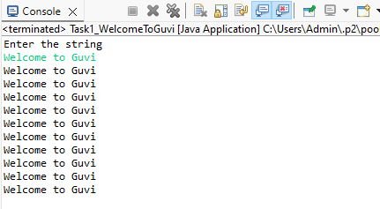

9) Program – Check person is a senior citizen or not:
package java_Tasks;

import java.util.Scanner;

public class Task1_Check_SeniorCitizen_OR_not {

public static void main(String[] args)
{
// TODO Auto-generated method stub
System.out.println("Enter the age of a person");
Scanner sc = new Scanner(System.in);
int age = sc.nextInt();
if (age < 60)
{
System.out.println("Person is not a senior citizen");
}
else
{
System.out.println("Person is a senior citizen");
}
sc.close();
}

}

Output:
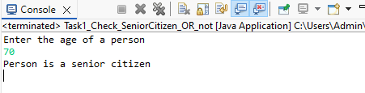
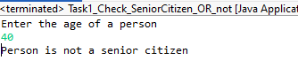

10) Program – Check number of digits in Integer

package java_Tasks;

import java.util.Scanner;

public class Task1_CountNumberOfDigits {

public static void main(String[] args)
{
// TODO Auto-generated method stub
int c = 0;
System.out.println("Enter the number");
Scanner sc = new Scanner(System.in);
int a = sc.nextInt();

while (a != 0) {
// num = num/10
a = a/10;
++c;
}

System.out.println("The Number of digits " + c);
sc.close();
}

}

Output:
